**Project Planning Phase**

**Project Planning Template (Product Backlog, Sprint Planning, Stories, Story points)**

|  |  |
| --- | --- |
| Date | 01 July 2025 |
| Team ID | LTVIP2025TMID37541 |
| Project Name | Citizen AI – Intelligent Citizen Engagement Platform |
| Maximum Marks | 5 Marks |

**Product Backlog, Sprint Schedule, and Estimation (4 Marks)**

Use the below template to create product backlog and sprint schedule

|  |  |  |  |  |  |  |
| --- | --- | --- | --- | --- | --- | --- |
| **Sprint** | **Functional Requirement (Epic)** | **User Story Number** | **User Story / Task** | **Story Points** | **Priority** | **Team Members** |
| Sprint-1 | Data Collection | USN-1 | As a developer, I want to collect and load datasets from available sources | 3 | High |  |
| Sprint-1 | Data Preprocessing | USN-2 | As a developer, I want to handle missing and categorical values in the dataset | 3 | High |  |
| Sprint-2 | Model Testing | USN-4 | As a developer, I want to test the model accuracy and performance | 3 | High |  |
| Sprint-3 | UI/Frontend | USN-5 | As a developer, I want to create the user interface using HTML/CSS | 3 | Medium |  |
| Sprint-3 | Deployment | USN-6 | As a developer, I want to deploy the model and UI using Flask | 5 | High |  |
| Sprint-3 | API Integration | USN-7 | As a developer, I want to build REST APIs for frontend-backend communication | 3 | High |  |
| Sprint-3 | Input Validation | USN-8 | As a developer, I want to validate form inputs to prevent bad or empty submissions | 2 | Medium |  |
| Sprint-2 | Database Setup | USN-9 | As a developer, I want to set up a database to store user queries and responses | 3 | High |  |
| Sprint-1 | Script Automation | USN-10 | As a developer, I want to automate data cleaning using a Python script | 2 | Medium |  |

**Project Tracker, Velocity & Burndown Chart: (4 Marks)**

|  |  |  |  |  |  |  |
| --- | --- | --- | --- | --- | --- | --- |
| **Sprint** | **Total Story Points** | **Duration** | **Sprint Start Date** | **Sprint End Date (Planned)** | **Story Points Completed (as on Planned End Date)** | **Sprint Release Date (Actual)** |
| **Sprint-1** | **8** | **6 Days** | **03 Jun 2025** | **09 Jun 2025** | **8** | **05 Feb 2025** |
| **Sprint-2** | **11** | **6 Days** | **10 Jun 2025** | **16 Jun 2025** |  |  |
| **Sprint-3** | **11** | **6 Days** | **17 Jun 2025** | **26 Jun 2025** |  |  |

**Velocity:**

Imagine we have a 10-day sprint duration, and the velocity of the team is 20 (points per sprint). Let’s calculate the team’s average velocity (AV) per iteration unit (story points per day)



**Burndown Chart:**

A burn down chart is a graphical representation of work left to do versus time. It is often used in agile[software development](https://www.visual-paradigm.com/scrum/what-is-agile-software-development/) methodologies such as [Scrum](https://www.visual-paradigm.com/scrum/scrum-in-3-minutes/). However, burn down charts can be applied to any project containing measurable progress over time.

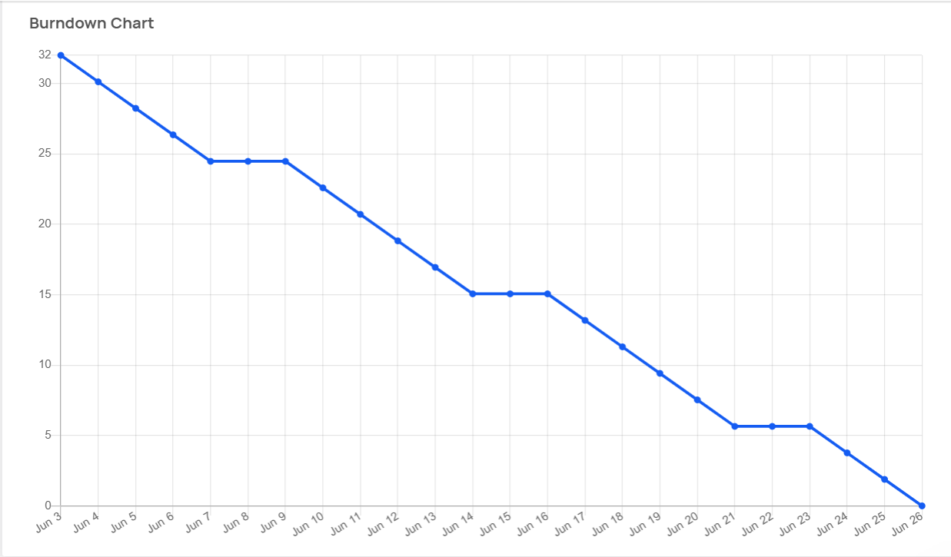

[**https://www.visual-paradigm.com/scrum/scrum-burndown-chart/**](https://www.visual-paradigm.com/scrum/scrum-burndown-chart/)

[**https://www.atlassian.com/agile/tutorials/burndown-charts**](https://www.atlassian.com/agile/tutorials/burndown-charts)

**Reference:**

[**https://www.atlassian.com/agile/project-management**](https://www.atlassian.com/agile/project-management)

[**https://www.atlassian.com/agile/tutorials/how-to-do-scrum-with-jira-software**](https://www.atlassian.com/agile/tutorials/how-to-do-scrum-with-jira-software)

[**https://www.atlassian.com/agile/tutorials/epics**](https://www.atlassian.com/agile/tutorials/epics)

[**https://www.atlassian.com/agile/tutorials/sprints**](https://www.atlassian.com/agile/tutorials/sprints)

[**https://www.atlassian.com/agile/project-management/estimation**](https://www.atlassian.com/agile/project-management/estimation)

[**https://www.atlassian.com/agile/tutorials/burndown-charts**](https://www.atlassian.com/agile/tutorials/burndown-charts)